

**PRESS RELEASE**

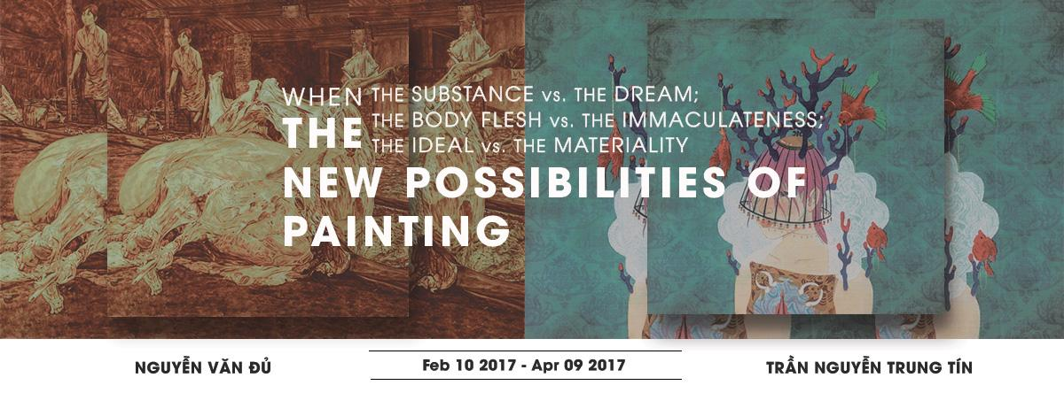

**‘When the Substance vs. The Dream; The Body Flesh vs. The Immaculateness;**

**The Ideal vs. The Materiality – The New Possibilities of Painting’**

A two-man show by Nguyễn Văn Đủ and Trần Nguyễn Trung Tín

Curated by Nguyễn Như Huy

Co-organized by Nguyễn Như Huy and ‘The Factory Contemporary Arts Centre’

10 February – 9 April 2017

*Public opening party: 17 February from 6.30pm*

In this two-man exhibition, Ho Chi Minh City based artists Nguyễn Văn Đủ and Trần Nguyễn Trung Tín demonstrate what curator Nguyễn Như Huy refers as a ‘Return of Painting’. Installed in the main ground-floor hall of ‘The Factory Contemporary Arts Centre (The Factory)’, their respective paintings on canvas and silk utilize unique material (animal blood and sound for example) taking the concept and technique of what constitutes ‘painting’ to a critically new space of interpretation in Vietnam.

Nguyễn Văn Đủ’s adept and gestural large scale canvases takes us behind the scenes, into the abattoirs of suburban Ho Chi Minh City; while Trần Nguyễn Trung Tín’s silk work, replete with specially composed sound, takes us into a fictional landscape where each painting becomes its own character of fancy.

Nguyễn Như Huy states ‘Đủ and Tín…. show two different approaches to painting. However, the curatorial point of this exhibition is that both artists go beyond the political battle between tradition and modernity, to enter the field of making new expressive possibilities in painting’.

This exhibition is accompanied by a full-color exhibition catalog with essay by curator Nguyễn Như Huy. This publication will be launched on the 25 February on the occasion of the ‘curator-artist’ talk at The Factory.

The Factory is pleased and honored to present the work of acclaimed emerging artistic talent in Ho Chi Minh City, this exhibition engaging the progress and innovation of painting today, a critically necessary project demonstrating what makes art ‘contemporary’.

For further enquiries, please contact:

Ms. Lê Thiên Bảo: bao.le@factoryartscentre.com | +84 (0) 837442589

*\*Image shows details of artworks ‘Slaughterhouse#16 2016’ by Nguyễn Văn Đủ and ‘Dolores 2016’ by Trần Nguyễn Trung Tín*

*-----*

**SPONSORS**

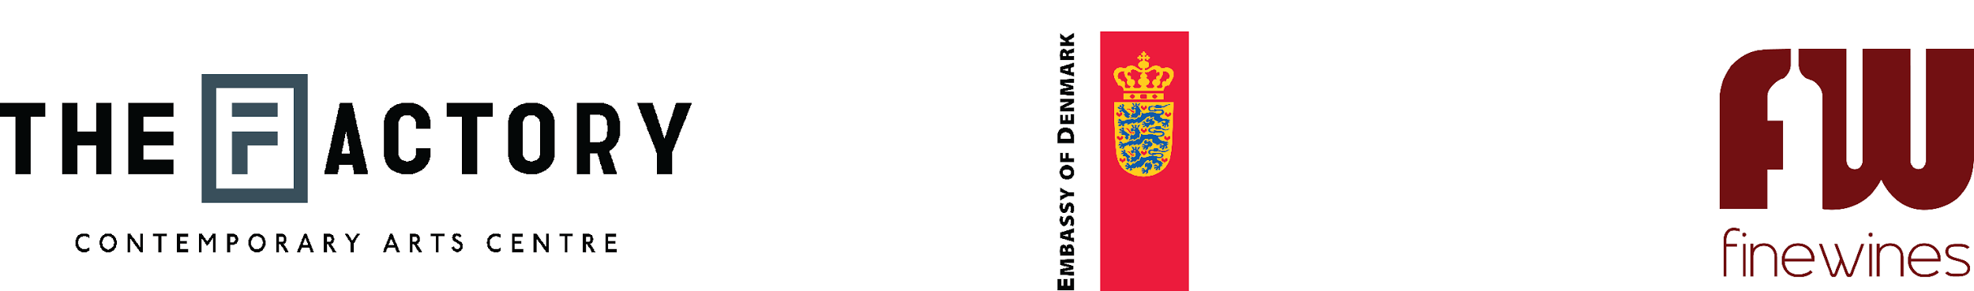

-----

Notes to the editor:

**Nguyễn Văn Đủ**(b.1986, Ho Chi Minh City, Vietnam)

Born in Ba Ria – Vung Tau, Nguyễn Văn Đủ ceaselessly learns and experiments with new media to bring his artworks to a more profound level. He graduated from the Ho Chi Minh City University of Fine Arts, majoring in Oil Painting, his paintings focusing on exploring personal perception, formed from the impact of education and daily routine of traditional culture in Vietnam (a post-war society). Intrigued by the way our habits are taught, Du is drawn to the ethical and moral questions behind nationalism and the violence that often ensues its pursuit. Đủ works majoritively in oil on canvas and watercolor on paper. However most recently he experiments with cow and human blood on various materials such as silk and paper.

**Trần Nguyễn Trung Tín**

(b.1992, Ho Chi Minh City, Vietnam)

Tín graduated from the University of Fine Arts majoring in silk painting and currently works as an artist and illustrator. Since Tín prefers to let art do the speaking for him, his drawings become a shade of his expressions - the more he learns about people, events, facts, objects, the more he realizes his inner self. He calls his portraits a “canvas for creativity”. Some of them show his true feelings about one particular person, whereas others are completely fictional, the creative visions combine to express a specific mood or thought on current events crossing his mind.

**Nguyễn Như Huy**

(b.1971, Ho Chi Minh City, Vietnam)

Nguyễn Như Huy is a visual artist, independent curator, art critic and poet. His practice concerns the relationship between present and past and the intervention of different temporal-spatial dimensions. His projects have been shown internationally in Japan, France, and USA. Như Huy has been writing, translating and publishing domestically and internationally on Vietnamese contemporary art, culture, and art theory, and has been guest speaker for several international conference such as “Vietnamese art post-Doi Moi”, which was held at Singapore Art Museum 2008; Asian Curator Conference organized by Japan Foundation 2010; and "Alternative Route: Art & Cultural Exchange In Asia" in Yokohama, Koganecho Bazaar project 2014. His poetry in 2015 was selected and published in Stand Magazine, England. He was co-curator for Singapore Biennale 2013 and since 2013 has been member of a curatorial advisory for the long- term project “Koganecho Bazaar”, Yokohama, Japan. Như Huy was guest curator for Brand New Project 2015, an annual initiative of Bangkok University that aims to introduce potential young Thai artists to Thailand’s contemporary art scene. Nhu Huy was co-curator of Kuandu Biennale 2016, as well as Artistic Director of the one-year Asian multiple activities and interdisciplinary festival ‘Asian In/Visible Station 2016-2017’ that is organized and curated by ‘ZeroStation’ in Ho Chi Minh City and funded by Asian Center, Japan Foundation.

Huy is founder and now Artistic Director of ZeroStation (www.zerostationvn.org). In general this is a project-based space with residency program for international artists and showcase space for local and international projects.

The main concept of ZeroStation is to develop the kind of contemporary art in Vietnam that is more engaged than spectacle, more critical than exotic. The main mission of ZeroStation is to create more opportunities for dialoguing, thinking, and working among local and international artists on social and cultural issues.

**The Factory Contemporary Arts Centre** (**“The Factory”**) is a creative hub established in April 2016 in Ho Chi Minh City. It aims to showcase and encourage further awareness of artistic and cultural expression in Vietnam, supporting the developing art scene of this country via curated exhibitions and a regular roster of public programs showcasing the interdisciplinary brilliance of local and international creative talent. “It’s important to me to build an art network in and for Vietnam that helps inspire and educate people by bringing art closer to the community” says founder-artist Ti-a. Possessing over 1000sqm, The Factory is not only Vietnam’s first purpose-built space for contemporary art, it also offers a publicly accessible library of art-educational resource; workshop and co-working space; replete with café, bar and restaurant. The Factory operates as a social enterprise, where all profit from businesses on-site supports the running costs of its art-related programs.

w[ww.factoryartscentre.com](http://www.factoryartscentre.com)