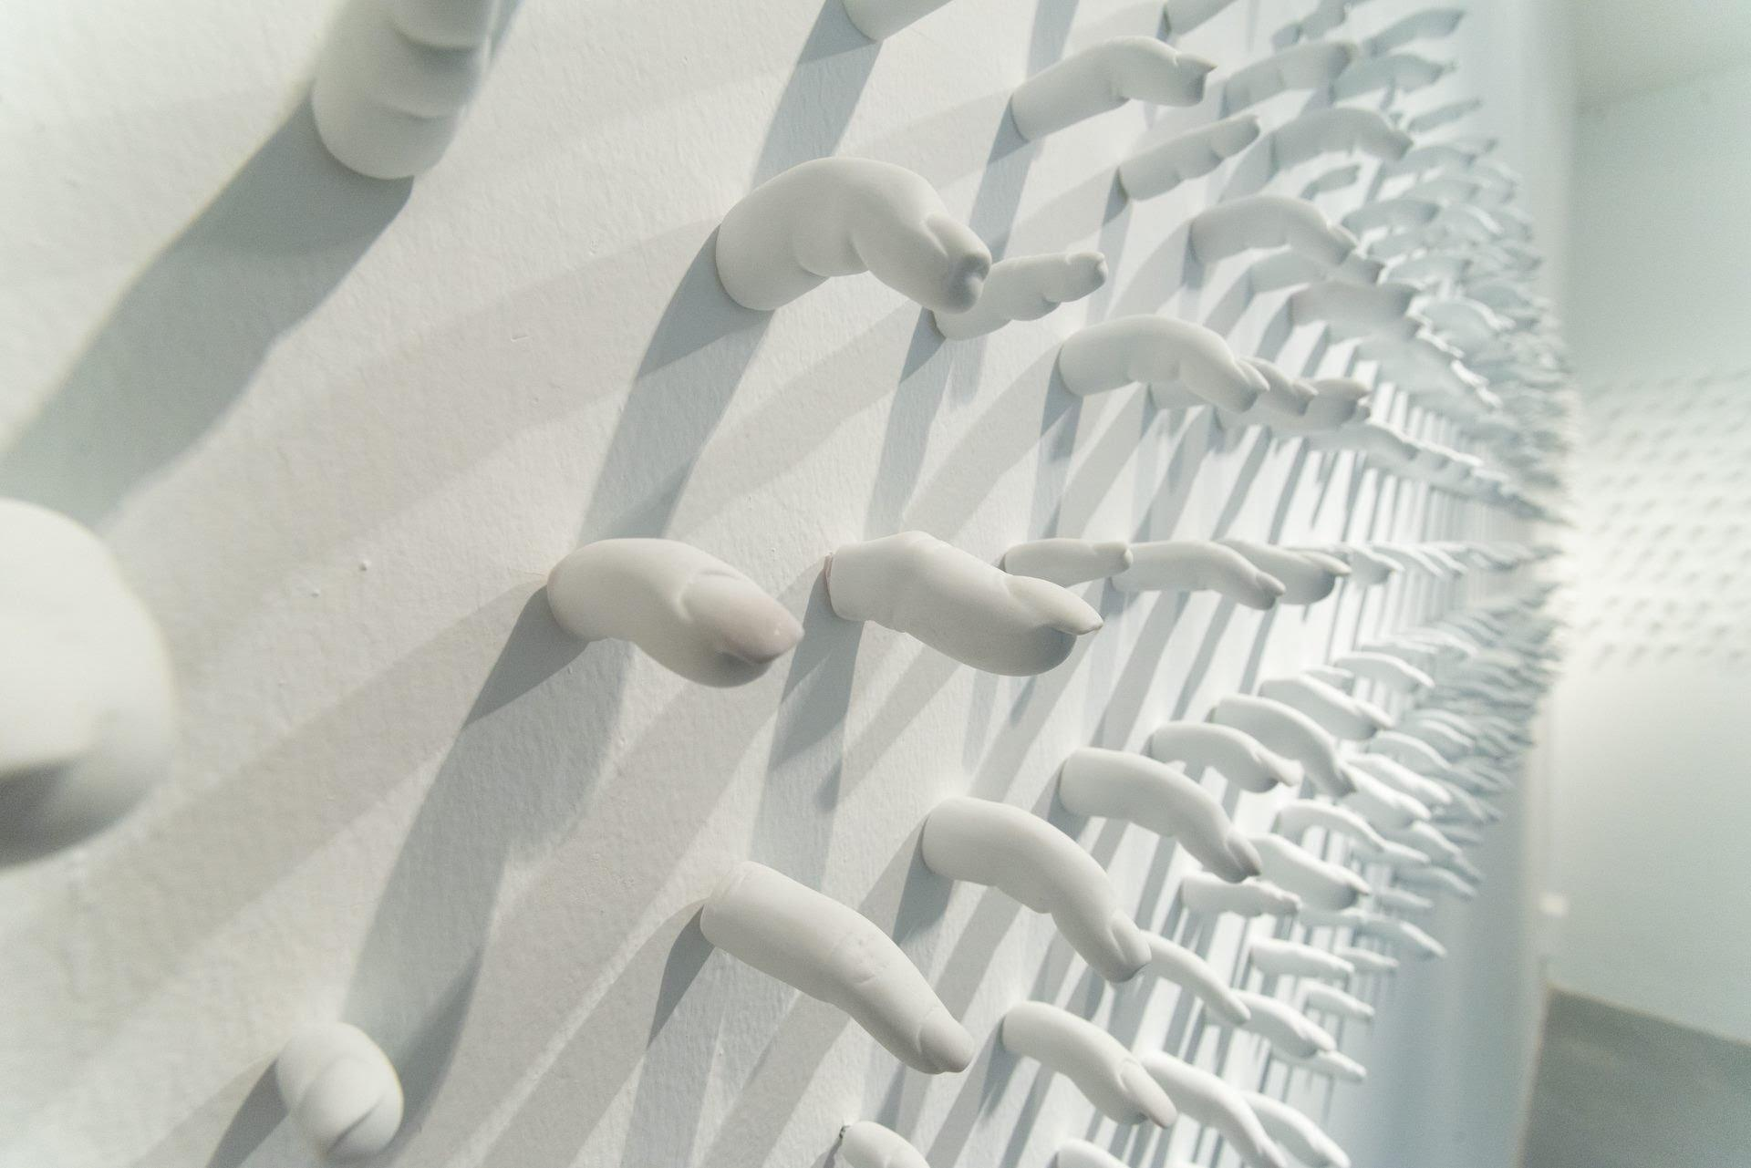

**CHAIN**

an exhibition by Lê Hoàng Bích Phượng

17/02 – 09/04/2017

Growing up in Vietnam in the 1980s – 1990s, when manga was newly imported and of rising interest in the country, Lê Hoàng Bích Phượng was inspired from Japanese popular comics such as Doraemon, Maruko and Sailor Moon. “Painting is like writing a diary, the only difference is memories are captured by painting language on a surface without lines…”, she said. Since the very early stage of her artistic career, Bích Phượng has passionately pursued an artistic practice using traditional materials. Her watercolor painting technique is meticulous. She approaches art-making intuitively, as if she was having a conversation with her innermost feelings while patiently layering colors on silk, until attaining the most satisfying tone and color gradation.

In the series *The Potato’s Portrait* (2016), Bích Phượng keeps the lightness usually found in her previous paintings. Her strong command of line and color creates graceful, ethereal compositions but presents a strong and drastic idea. She relates the connection between soil, potato and ambition of humanity in a very unique way: “…soil represents the human body, the image of life. Potato, a nutrient-dense vegetable, may possibly become poison for us. Apart from digesting nutrition to supply the operation of the human body, we also consume an enormous amount of dreams to maintain a spiritual life. Potatoes are like dreams growing inside us. Harvesting them at the right time may offer an abundant crop, but sometimes we would like to keep hope to grow them bigger under the ground. When dreams are getting bigger they soon become greed, just like when a potato sprouted, its nutrition becomes poisonous. This toxin spreads insidiously and grows with time. The soil which gave life to good, could have also raised the bad. From there, the circulation continues, like karma.”

This exhibition is also a new experiment for Bích Phượng to challenge herself, combining new ideas about the ethereal correlation of karma in Buddhist ideology with Vietnamese traditional porcelain techniques. She creates a ‘world’ in which the installation *Milky Way* (2015), includes 999 index fingers, all handmade from white porcelain with the support of talented traditional artisans from Bát Tràng village These are lined on a white wall as a long chain of critiques, ambitions and orders, pointing at us. Each finger is like a small planet in the Milky Way, just like the tiny existence of humanity in the universe.. In this ‘universe’, there also is a *Black Hole* (2015), an installation of 4 pomegranates on which many golden fingers parasitized and distorted, displayed on a white pedestal in darkroom. According to ancestor worship culture in Vietnam, pomegranate represents fertility and abundance; gold represents eternity and perfection. The fingers sprouted on the pomegranate is symbolic of the greed and selfishness exhausting the subsistence of life.

To Bích Phượng, all of us are as random as the creation of planets. Born, then strung together in a cluster like a galaxy, an asymmetrical chain. Following our creation, we are impacted and influenced by each other. Like asteroids, actions create sequences we can at times anticipate. Other impacts set in motion unintended consequences. We seek and chase the broader spaces. We pay no mind to the effects they may cause surrounding planets. Somehow, we deviate from the universal system of order. Our path breeds jealousy, as we seek greener pastures just over the horizon. It is her belief that peaceful consciousness instills order. It is in fact our forgotten ‘promised land’ - abandoned in pursuit of meandering dreams.

The artist would like to thank The Vietnamese – Danish Culture & Development Exchange Fund (CDEF) for production support. The exhibition is organized by The Factory Contemporary Arts Centre from 17/02 to 09/04/2017.



For further inquiries, please contact:

Lê Thiên Bảo (Ms.)

Email: [bao.le@factoryartscentre.com](mailto:bao.le@factoryartscentre.com)

Mobile: +84 (0)938 959 652

------

*Exhibition information:*

Venue: The Factory Contemporary Arts Centre

15 Nguyen U Di, Thao Dien, District 2, Hồ Chí Minh City, Vietnam

www.factoryartscentre.com

Opening time: 10AM – 7PM from Tue to Sun.

-------

*Notes for editor:*

**Lê Hoàng Bích Phượng**

(b.1984, Ho Chi Minh city, Vietnam)

A graduate of the Ho Chi Minh City Fine Arts University, major of Oil Painting in 2010 and in the same year, she is one of the finalists of Talented Award by The Vietnamese – Danish Culture & Development Exchange Fund (CDEF), but Bích Phượng soon found her passion with silk. She is one of Vietnam’s most promising young artists who is influenced by Japanese manga during her childhood. Incorporated with her study and deep research about Vietnamese traditional silk painting, Bích Phượng has greatly formed her own unique style and technique. Her artworks focus on the emotional interaction between humans, thereby forming social relationships, then developing into behaviors and conventions. In 2011, she was awarded an artist-in- residence in Sapporo, Japan, as part of the ‘JENESYS Program: Invitation Program for Creators’ of the Japan Foundation and that same year was also one of the finalists for the DOGMA Art Prize in self-portraiture. In 2010 she was finalist in the ‘Talent Prize’ of the Cultural Development and Exchange Fund.

Most recent exhibitions:

2016 *Bittersweet Whispers*, Salon Saigon, HCMC, Vietnam

2015 *Trắng, Đen & Vàng |* *White, Black & Gold*, The Japan Foundation, Hanoi, Vietnam

2012 *Thay hình đổi dạng | A Transformative Disguise*, Sàn Art, HCMC, Vietnam & The Japan Foundation, Hanoi, Vietnam

2011 *Sapporo Biennale 2011*, Sapporo, Japan

*Họa một nét hoa | Shaping a line*, Sàn Art, HCMC, Vietnam

*Đương đại Sài Gòn | Saigon Contemporary*, La Lanta Fine Art Gallery, Bangkok, Thailand

**The Factory Contemporary Arts Centre** (**“The Factory”**) is a creative hub established in April 2016 in Ho Chi Minh City. It aims to showcase and encourage further awareness of artistic and cultural expression in Vietnam, supporting the developing art scene of this country via curated exhibitions and a regular roster of public programs showcasing the interdisciplinary brilliance of local and international creative talent. “It’s important to me to build an art network in and for Vietnam that helps inspire and educate people by bringing art closer to the community” says founder-artist Ti-a. Possessing over 1000sqm, The Factory is not only Vietnam’s first purpose-built space for contemporary art, it also offers a publicly accessible library of art-educational resource; workshop and co-working space; replete with café, bar and restaurant. The Factory operates as a social enterprise, where all profit from businesses on-site, including sale of art on view, supports the ongoing costs of its art-related programs. [www.factoryartscentre.com](http://www.factoryartscentre.com)